Experiment 05 - Clustering using RapidMiner

Tool

| Roll No. |  |
| --- | --- |
| Name |  |
| Class | D15A |
| Subject | Business Intelligence Lab |
| LO Mapped | LO2: Organize and prepare the data needed for data  mining algorithms in terms of attributes and class inputs,  training, validating, and testing files.  LO3: Implement the appropriate data mining methods like  classification, clustering or association mining on large  data sets using open source tools like WEKA |
| Grade |  |

**Implementation:**

**K-means clustering -**

Process -

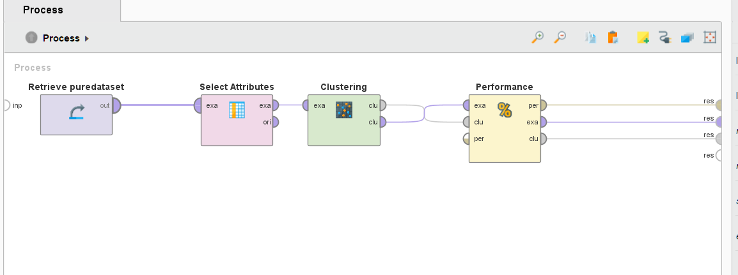

Output -

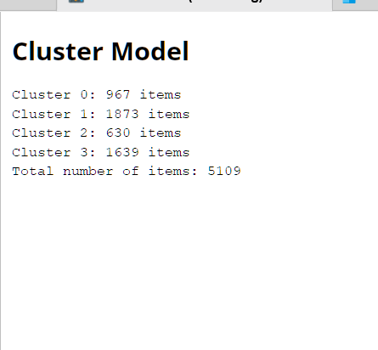

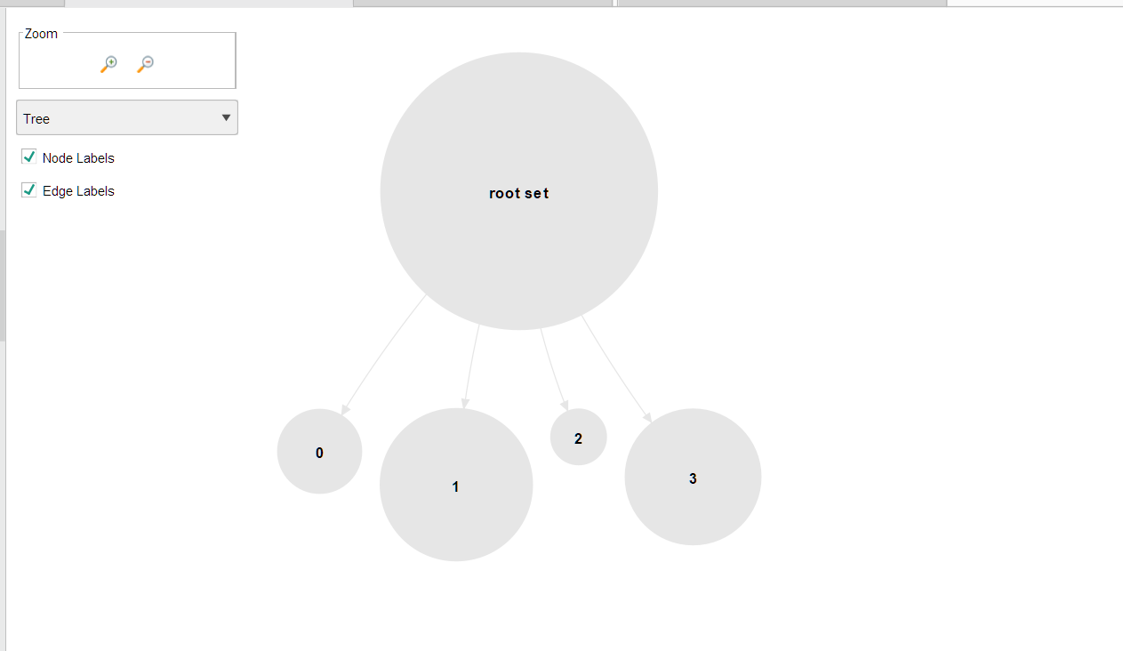

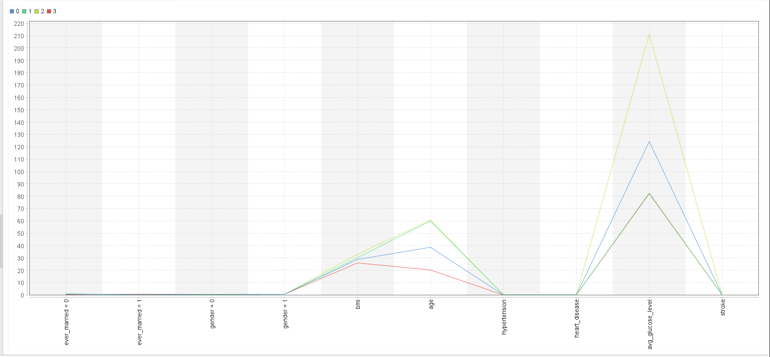

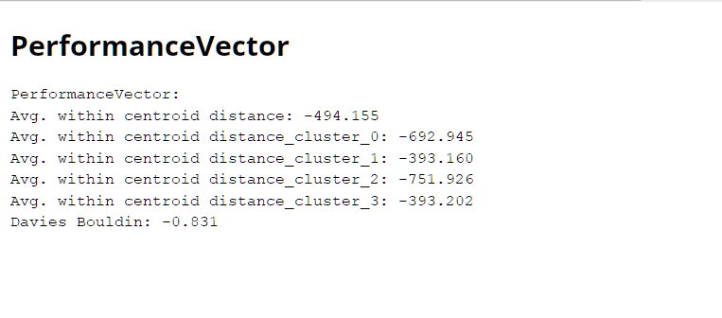

**Hierarchical clustering -**

Process -

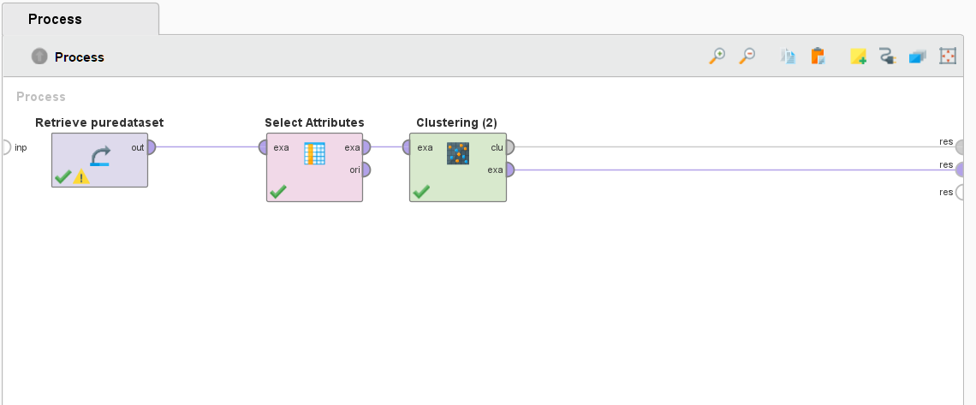

Output -

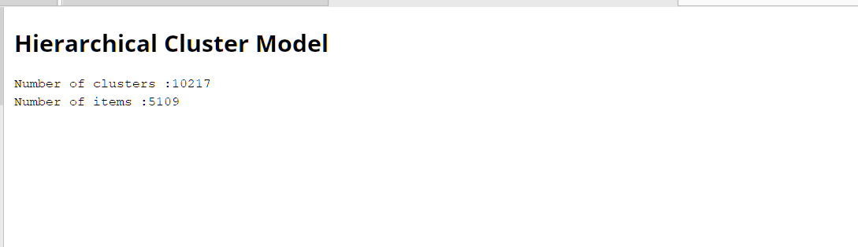



**DBSCAN -**

Process -

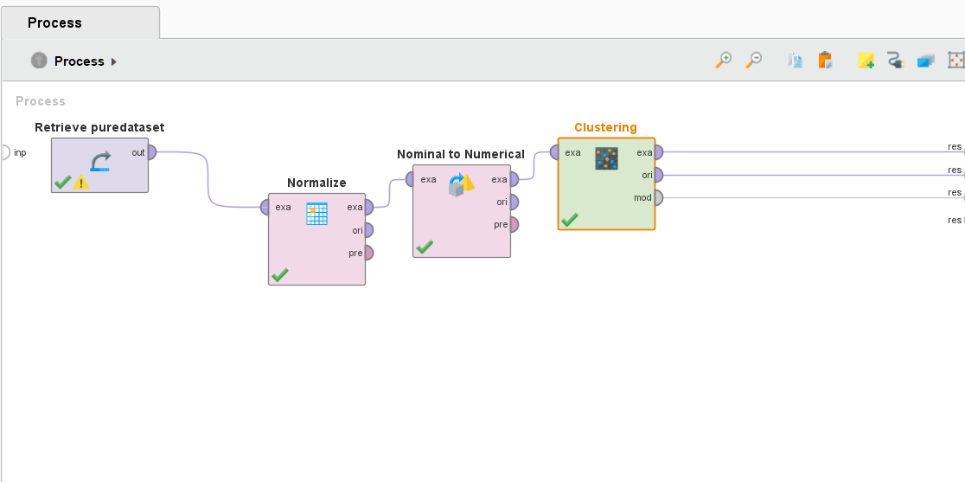

Output -

